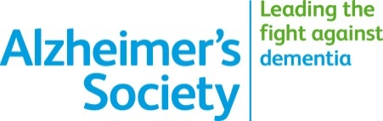

Alzheimer’s Research in Cumbria

Opportunity and invite for Alzheimer’s patients & carers to take part

1) Alzheimer’s Disease Genetics

This study looks at genetic factors (inheritance of DNA) and
their potential role in Alzheimer’s disease.

It involves a one-hour visit for patient & carer, during which
one blood sample and a questionnaire needs to be completed
(may be done with supervision; visit can be split in two)

2) MODEM – Eye movement for diagnosis

This study looks into how eye movement may be used as a
diagnostic tool for Alzheimer’s disease. No involvement for carers,
apart from giving assent for patient to enrol.

It involves a two-hour visit for the patient, during which
a non-invasive eye-test will be undertaken
and some questionnaires are completed (again, with
supervision if indicated)

Thank you for considering taking part.

Interested? Contact Details

Please contact the Research Department of Cumbria Partnership NHS if you wish to consider taking part. An expression of interest DOES NOT mean that you (or your relative) have to take part. You may change your mind or you may not be eligible.

Contact – Research & Development Department
Email – research@cumbria.nhs.uk
Address – E23 Ruskin Corridor, The Carleton Clinic, Cumwhinton Drive, Carlisle, Cumbria, CA1 3SX

Research reply slip

Yes, I am potentially interested in taking part in a clinical research study

Name of research study (if known) or area: …………………………………….

My name: …………………………………..

(please indicate if you are carer of a patient)

My preferred mode of correspondence: phone / letter / e-mail (please select those that apply)

Depending on your preference, please complete the relevant section below:

Phone number: ………………………………………………..

Address: ……………………………………………….

…………………………………………………….

……………………………………………………

e-mail address: ………………………………………………..

Contact – Research & Development Department
Email – research@cumbria.nhs.uk
Address – E23 Ruskin Corridor, The Carleton Clinic, Cumwhinton Drive, Carlisle, Cumbria, CA1 3SX

